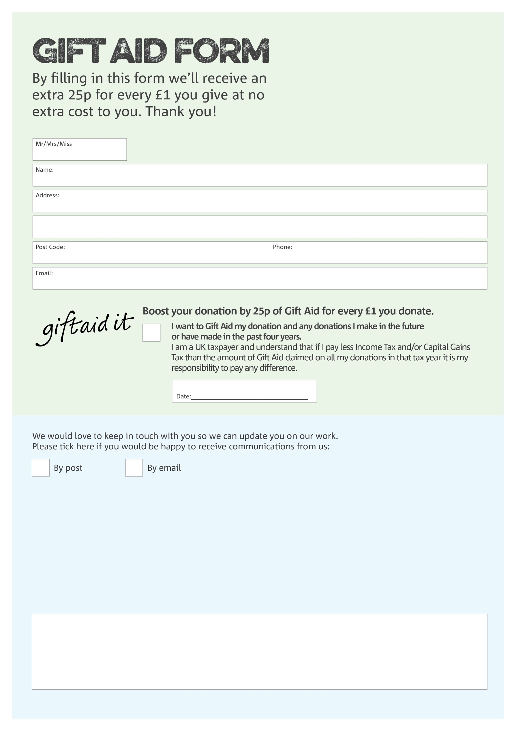 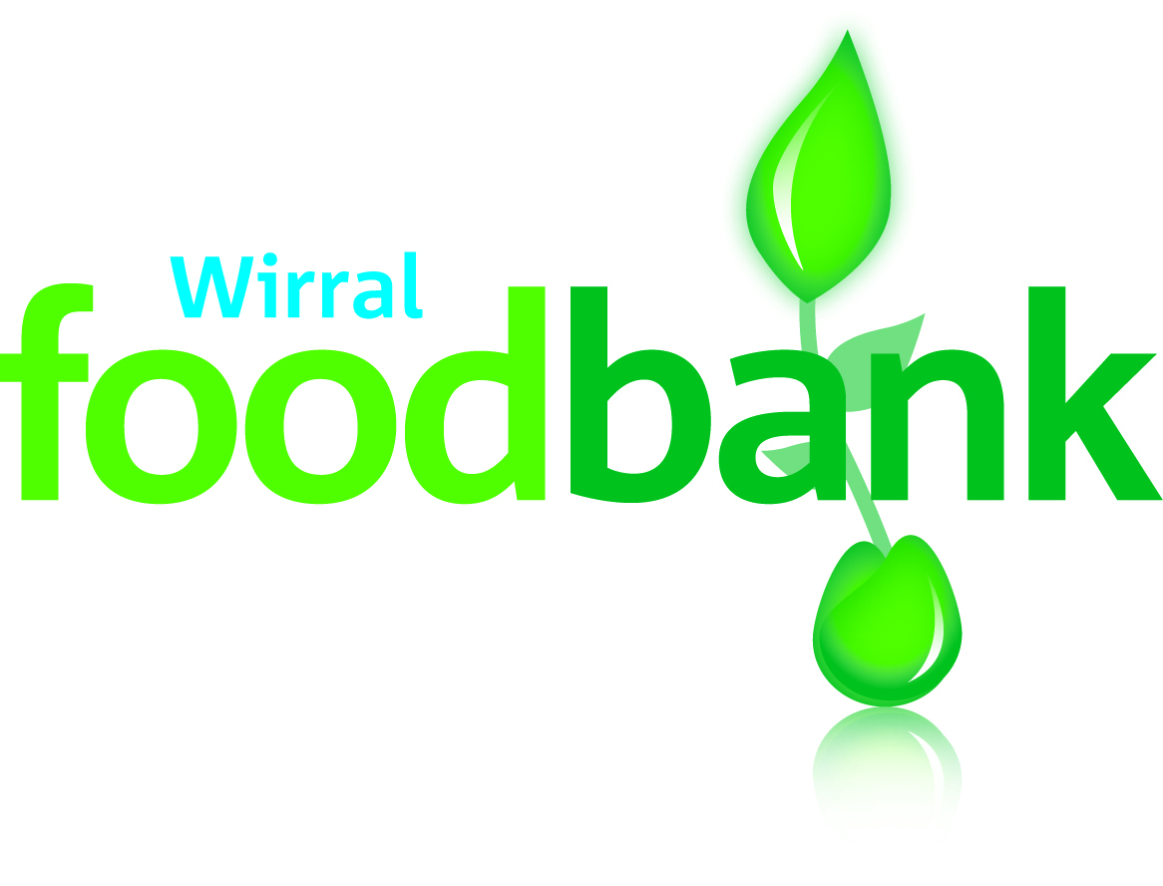

Charitable incorporated organisation registered in England with charity number 1167967 **Issued April 2017**

Signature _________________________________________________________

You can change your preferences any time by contacting us on 0151 638 7090 or emailing us at [enquiries@wirralfoodbank.org.uk](mailto:enquiries@wirralfoodbank.org.uk)

**Data protection**

Wirral Foodbank is committed to protecting your privacy and will process your personal data in accordance with the Data Protection Act 1998. Wirral Foodbank collects information to keep in touch with you and supply you with information relating to our work. Wirral Foodbank will never sell or pass your details to anyone who isn’t directly working on our behalf.

We would love to know why you have chosen to donate to Wirral Foodbank. If you would like to share your motivation let us know below:

Charity Number XXXXXX. Registered in XXXXXXX