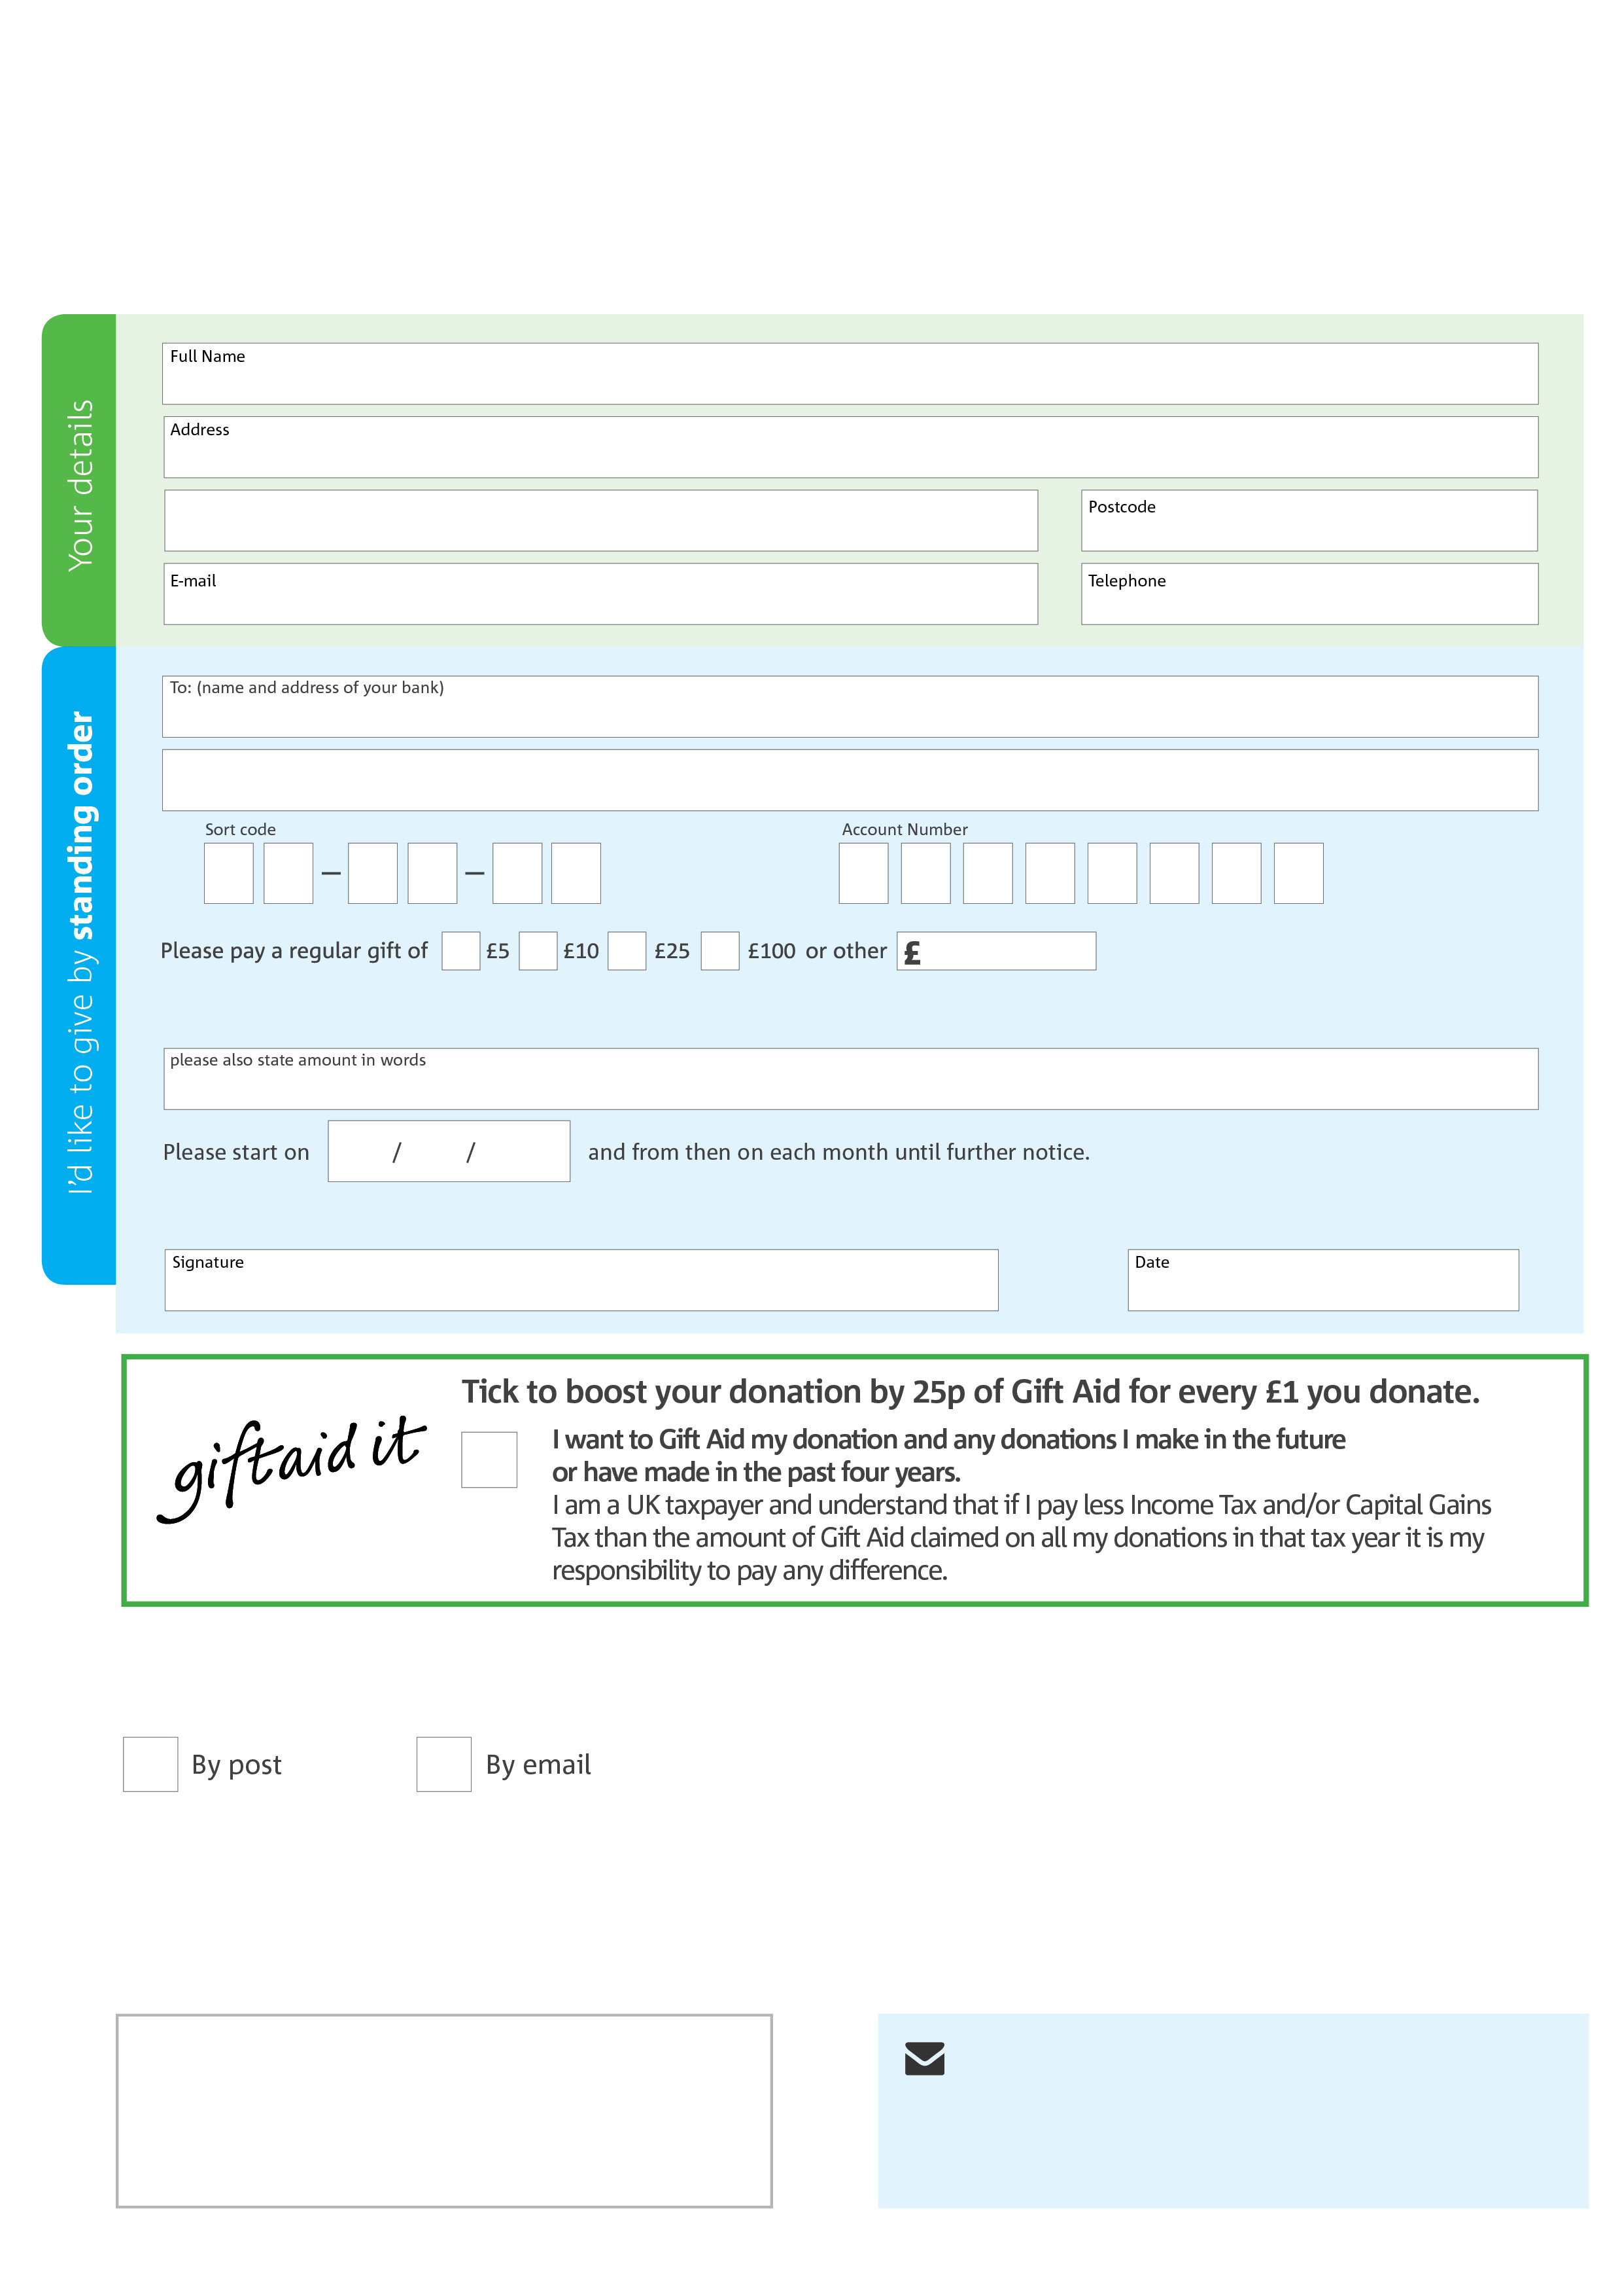 ­



**Data protection**

Wirral Foodbank is committed to protecting your privacy and will process your personal data in accordance with the Data Protection Act 1998. Wirral Foodbank collects information to keep in touch with you and supply you with information relating to our work. Wirral Foodbank will never sell or pass your details to anyone who isn’t directly working on our behalf.

**We would love to keep in touch with you so we can update you on our work. You can change your preferences any time by contacting us on 0151 638 7090 or emailing us at enquiries@wirralfoodbank.org.uk**

**Please tick here if you would be happy to receive communications from us:**

**Wirral Foodbank’s bank details:**

HSBC

31 The Pyramids

BIRKENHEAD CH41 2ZL

Sort code: 40-10-22

Account No: 42265508

**Please send your completed form to**

Wirral Food Bank Office

Unit 14 Wirral Business Centre

Dock Road

Birkenhead

CH41 1JW

This cancels any previous standing order instructions to Wirral Foodbank

To Wirral Foodbank each month,

Reg. Charity No: 1145123 | Reg. in England & Wales Issued April 2016